PART 1

1. In the first part of the test you need to build a custom view (SQL code) to transform and normalize data according to the scheme and fields description below.

Please write SQL-code to get the Result table from the initial 5 tables, scheme below:

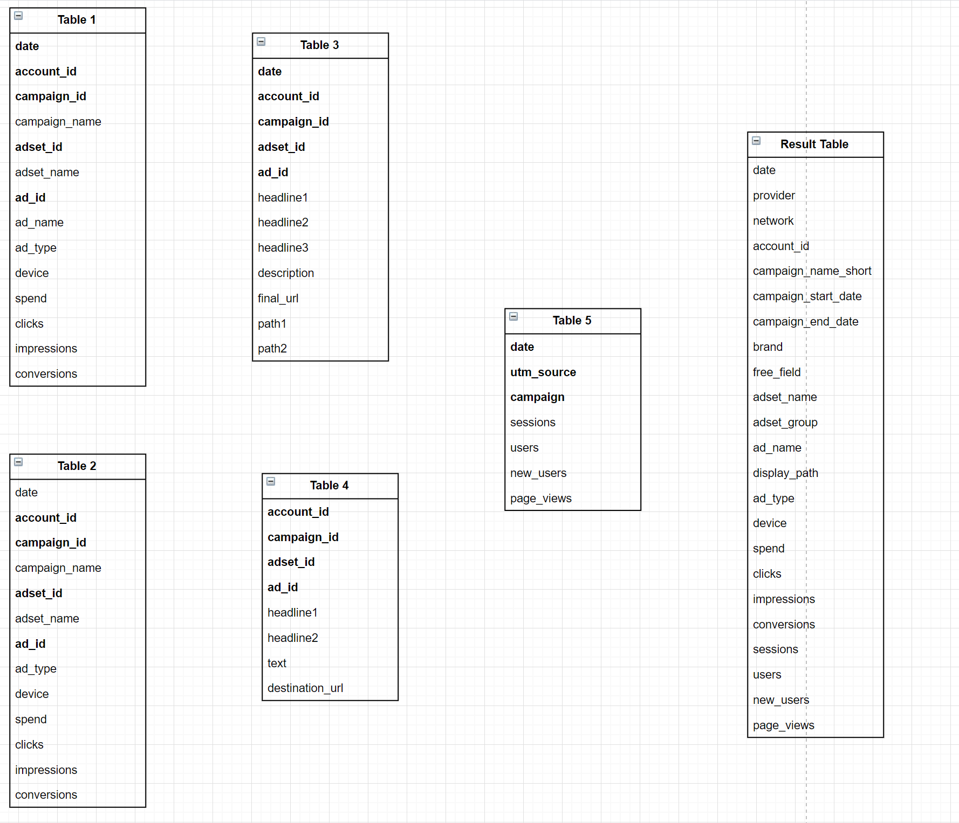

**Tables descriptions:**

1. “Table 1” contains advertising data for the first platform and has the **ads_device** level of granularity.  
     
   **Fields:**

* date (*dimension*) - **join** **key**, date when data was published at the platform.
* account_id (*dimension*) - **join** **key**, ID of the advertising account
* campaign_id (*dimension*) - **join** **key**, ID for the advertising campaign
* campaign_name (*property*) - advertising campaign name
* adset_id (*dimension*) - **join** **key**, ID for the group of ads
* adset_name (*property*) - name of the group of ads
* ad_id (*dimension*) - **join** **key**, ID for the ad
* ad_name (*property*) - name of the ad
* ad_type (*property*) - type of ad
* device (*dimension*) - device type where the impression was shown.
* spend (*metric*) - amount of fact budget
* clicks (*metric*) - amount of clicks
* impressions (*metric*) - amount of impressions
* conversions (*metric*) - amount of conversions

**Additional part:**

1. Table 1 needs to add additional fields *provider* as text **“Platform 1”**, *network* as text **“channel 1”** - channel of data for first platform.
2. *campaign_name* field has the following structure: “*_CN|{campaign_name_short}_BR|{brand}_FF|{free_field}*” need to parse **campaign_name_short**, **brand**, **free_field** properties to include them in the final table.
3. In the final table also should be included field **adset_group** which can be extracted from *adset_name* field with the structure: “*{adset_group} | {text 1} | {text 2}”*
4. “Table 2” contains advertising data for the second platform and has the same **ads_device** level of granularity.  
     
   **Fields:**

* date (*dimension*) - **join** **key**, date when data was published at the platform.
* account_id (*dimension*) - **join** **key**, ID of the advertising account
* campaign_id (*dimension*) - **join** **key**, ID for the advertising campaign
* campaign_name (*property*) - advertising campaign name
* adset_id (*dimension*) - **join** **key**, ID for the group of ads
* adset_name (*property*) - name of the group of ads
* ad_id (*dimension*) - **join** **key**, ID for the ads
* ad_type (*property*) - type of ads
* device (*dimension*) - device type where the impression was shown.
* spend (*metric*) - amount of fact budget
* clicks (*metric*) - amount of clicks
* impressions (*metric*) - amount of impressions
* conversions (*metric*) - amount of conversions

**Additional part:**

1. “Table 2” needs to add additional fields *provider* as text **“Platform 2”**, *network* as text **“channel 2”** - channel of data for second platform.
2. *campaign_name* has the following structure: *“_CN|{campaign_name_short}_BR|{brand}_FF|{free_field}”* need to parse **campaign_name_short**, **brand**, **free_field** properties to include them in the final table.
3. In the final table also should be included field **adset_group** which can be extracted from *adset_name* field with the structure: “*{adset_group} | {text 1} | {text 2}”*
4. “Table 3” contains missing properties for the “Table 1” for the first platform.  
     
   **Fields:**

* date (*dimension*) - **join** **key**,date when data was published at the platform.
* account_id (*dimension*) - **join** **key**,ID of the advertising account
* campaign_id (*dimension*) - **join** **key**, ID for the advertising campaign
* campaign_name (*property*) - advertising campaign name
* adset_id (*dimension*) - **join** **key**, ID for the group of ads
* ad_id (*dimension*) - **join** **key**, ID for the ads
* headline 1 (*property*) - the first part of an expanded text ad headline in the ad form
* headline 2 (*property*) - the second part of an expanded text ad headline in the ad form
* headline 3 (*property*) - the third part of an expanded text ad headline in the ad form
* description (*property*) - the descriptive text of an expanded text ad or responsive display ad
* final_url (*property*) - final URLs of the ad
* path1 (*property*) - the text that appears in the ad with the displayed URL for an expanded text ad
* path2 (*property*) - in addition to "Path1", more text that appears in the ad with the displayed URL for an expanded text ad.

**IMPORTANT NOTE:**

Data may have different *headline 1* or *headline 2* properties for the same *ad_id*, you need to take the **last value according to the max date**.

1. “Table 4” contains missing properties for the “Table 2” for the second platform.

**Fields:**

* account_id (*dimension*) - **join** **key**, ID of the advertising account
* campaign_id (*dimension*) - **join** **key**, ID for the advertising campaign
* adset_id (*dimension*) - **join** **key**, ID for the group of ads
* ad_id (*dimension*) - **join** **key**, ID for the ads
* headline 1 (*property*) - the first part of an expanded text ad headline in the ad form
* headline 2 (*property*) - the second part of an expanded text ad headline in the ad form
* text (*property*) - the descriptive text of an expanded text ad or responsive display ad
* destination_url (*property*) - final URLs of the ad

1. “Table 5” contains data from the third platform (analytic).

**Fields:**

* date (*dimension*) - **join** **key**, date when data was published at the platform.
* utm_source (*dimension*) - **join** **key**, utm source on site, can take two values (“Platform 1”, “Platform 2”)
* campaign (*dimension*) - **join** **key**, the lowercase of *campaign_name_short* field
* sessions (*metric*) - the total number of sessions
* users (*metric*) - the total number of users for the requested time period
* new users (*metric*) - the number of sessions marked as a user's first sessions
* page_views (*metric*) - the total number of pageviews for the property

**Description of result table:**

**Fields to be included:**

* **date**
* **provider** - *provider* as text **“Platform 1”** for first platform and **“Platform 2”** for second platform
* **network** - *network* as text **“channel 1”** - channel of data for first platform and **“channel 2”** - channel of data for second platform
* **account_id**
* **campaign_name_short** - property from the original *campaign_name* field (see point 2 in “additional part” section for table 1 and 2)
* **campaign_start_date** - fact start of campaign where data has been appeared (min date)
* **campaign_end_date** - fact end of campaign where data has been finished (max date)
* **brand** - property from the original *campaign_name* field (see point 2 in “additional part” section for table 1 and 2)
* **free_field** - property from the original *campaign_name* field (see point 2 in “additional part” section for table 1 and 2)
* **adset_name**
* **adset_group** - property from the original *adset_name* field (see point 3 in “additional part” section for table 1 and 2)
* **ad_name** - concatenate of {headline 1} | {headline 2} | {headline 3}
* **display_path** - concatenate of first part (before the end of domain) of *final/destination_url* like ([www.walmart.com](http://www.walmart.com)) + / + *path1* + / + *path2*
* **ad_type**
* **device**
* **spend**
* **clicks**
* **impressions**
* **conversions**
* **sessions**
* **users**
* **new_users**
* **page_views**

Below you can find the dummy data - each tab associated with the table from the task above:

1. Download csv files from spreadsheet
2. Insert the data to their local DB or use any trial online services like GBQ
3. Build the custom transformation based on this data.

**Dummy data:**

<https://docs.google.com/spreadsheets/d/12-eScxaQFCtCz3r9v-MgcPiwEzb-r54gvZcDGBo4Piw/edit#gid=268862596>

**Requirements to the code style:**

1. Please use CTE in your SQL to make code more readable and get the possibility to use multi-level aggregation.
2. All **SQL Operators** including (AS) functions must be **capitalized**
3. **Table names** and **column names** should be **lowercased**
4. Separate arithmetic operatorswith **space** on the right and on the left.
5. Also the best practise is put **space** after **comma**

Part 2

Build test dashboard in **Tableau**:

Need to connect the custom view from the first part of the test and based on this data model build a few widgets:

1. Text header “Test Performance Dashboard”
2. Date control filter
3. Cards with *campaign_start_date* and *campaign_end_date*
4. Filtersby Platform, Brand, Campaign (*campaign_name_short*)
5. Text header for performance indicators
6. Cards for advertising and analytics metrics including calc fields (CTR %, CPC, CPM, Pages per Sessions)
7. Two dynamic filters for chart:
   1. For time granularity (logic: *daily, monthly, yearly*), excluding *dynamic* mode
   2. For metrics (*clicks, cpc, cpm, ctr, impressions, spend*)

8. Chart **X-Axis - form of date**, **Y-Axis - metrics**, with possibility to switch date granularity and metrics according with filter from point #7.

9. Matrix widget for metrics (*Spend, Impressions, Clicks, CTR %, CPC, CPM, Sessions, Users, New Users, Pages Views, Page per Sessions*) by campaigns.

**Mockup:**

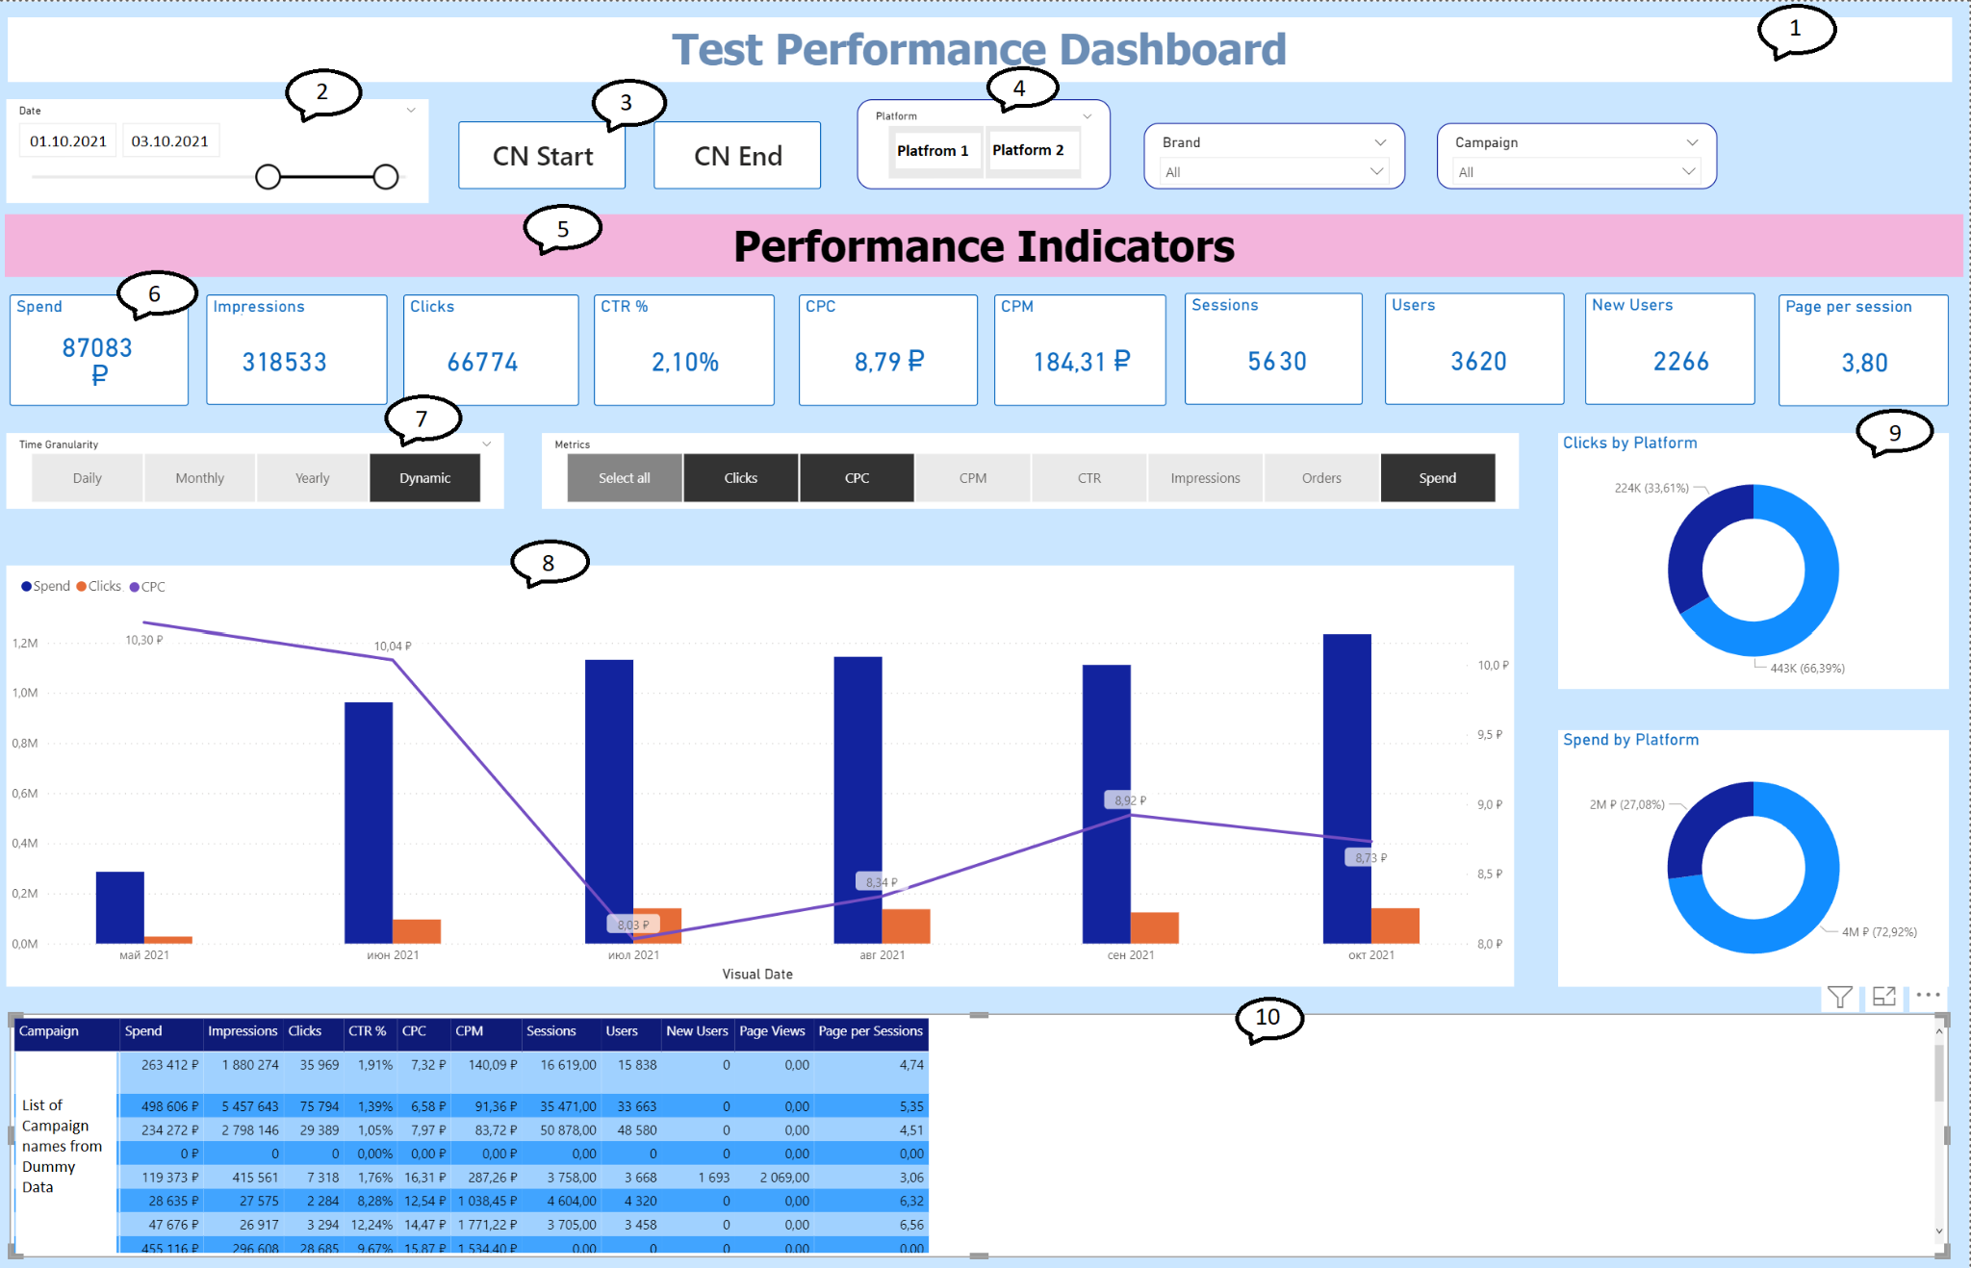

*P.S. Please use any style to build the dashboard (colors, sizes etc.) - mockup is just an example how it may look like.*